I. Introduction
A. System Overview
The industrial complex is designed for coal crushing, stockpiling, and transfer. It includes a belt conveyor system and several process units.

B. Control Concept
Each process unit (crusher, stacker, etc.) has an operator who monitors and controls its equipment. The central control room (hereinafter referred to as the CCR) is staffed by two operators, each responsible for one half of the complex, including the process units mentioned above.
C. Automation and Control System Architecture
The system uses Siemens PCS 7 v7.1 and WinCC v7.5. Each process unit has a Siemens CPU 416 controller (AS) and an operator visualization station (HMI/OS). The server room contains two redundant WinCC servers and an engineering station. The overall configuration is based on a standard PCS 7 project.
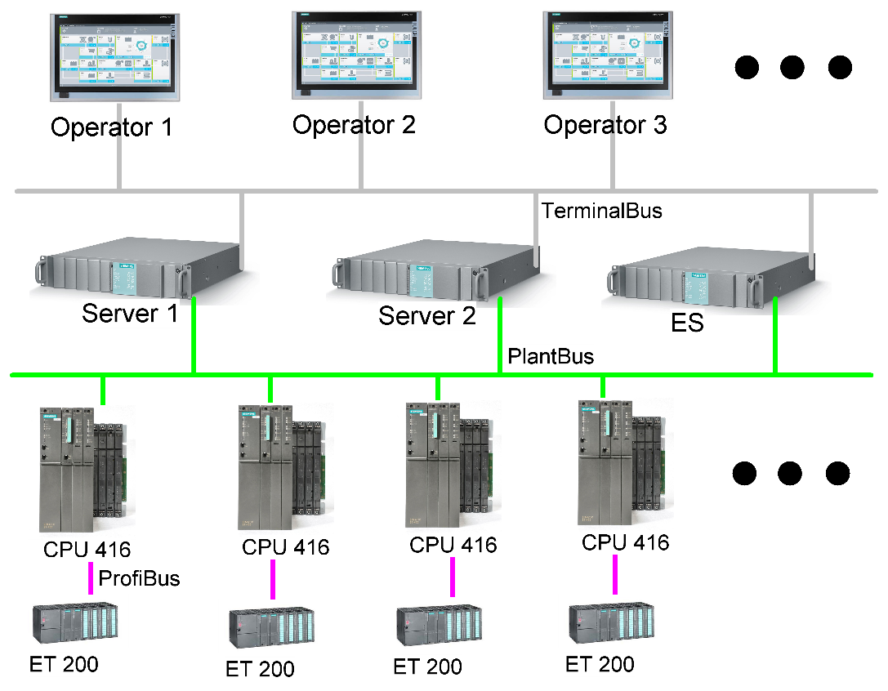
Automation and Control System Architecture

The visualization system originally consists of two projects: Server and Client. All clients are Client References to the “master” client. In practice, all clients are identical; the only differences are the computer names, IP addresses, and minor workstation-specific settings. Operators in the CCR use standard industrial PCs (IPCs), while operators at the process units use HMI PCs (all-in-one computers with touchscreens).
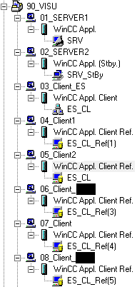
WinCC Architecture
D. Problem Statement
1. A Large Number of Units to Monitor
Excluding standalone process units (each staffed by its own operator), the conveyor system is monitored directly from the CCR. There are 12 conveyors, each with hundreds of limit switches. Operators must also stay informed about events at standalone units, since they are responsible for ensuring uninterrupted operation.
2. Inability to Monitor All Events Simultaneously
When the operator views a single screen showing all conveyors, it is not immediately clear what caused the entire line to stop. To check the equipment status, the operator must open the relevant process-unit screen. If the whole line stops, it may take time to identify which conveyor or process unit caused the stoppage.
3. Alarm Logging Messages
An event line at the top of the operator screen displays warnings, alarms, and other messages in real time. However, because a large number of messages arrive, they quickly replace one another. As a result, the operator may not notice an important message or may miss it entirely, potentially leading to a subsequent shutdown.

II. Requirements
A. Required System Functions
The system must provide an audible notification when a condition causing a line stoppage occurs, as well as for warnings of potential stoppages.
The system must allow each signal to be configured either to require acknowledgement or to play only once. It must also be possible to select whether a sound plays once or repeats until the triggering condition clears.
The system must be scalable, allowing additional sounds to be added.
Each WinCC OS client must play only the sounds assigned to that client.
Operators must be able to disable sound groups for equipment whose events they do not wish to hear. These groups are referred to below as “listening groups.”
Sound notifications must not overlap. All events registered by the system must be played sequentially in a queue.
Future scaling and an increase in the number of sounds must not interrupt production due to additional load on the PLC (AS) and/or visualization system (OS).

B. Why Use Voice Messages?
Because there are many signals, voice messages were chosen as the notification format. Each voice message follows the structure Unit–Cause. For example: “Conveyor 1 – belt mistracking.”

C. Why the Standard WinCC Horn Was Not Used
The standard Horn function does not provide sufficient flexibility for this application.
Horn is tied to the alarm acknowledgement mechanism.
Audio notification is linked to the alarm/acknowledgement state.
It is not possible to implement independent handling scenarios properly for different events.
There is no adequate message queue.
Sounds cannot be separated by client.
Event groups cannot be managed.
Operator intervention is required.

III. From Idea to Architecture
A. General Concept
I came across a script online that played a WAV file when a BOOL tag changed state. This was close to what I needed. After modifying it, I created code that plays a specific sound based on an INTEGER tag value. For example, if the tag value is 56, the script plays 056.wav. However, writing a separate script for every signal would have been tedious and time-consuming, so I decided to have the PLC generate the event number. The only thing the PLC now needs to do is send the number of the event whose sound should be played. As it turned out, the implementation was more challenging than I had expected.
As shown in the diagram, there are two PLCs, each sending its own event number. The server receives these values and makes them available to the clients. On each client, a script selects the sound folder based on the computer name and selects the sound file based on the event number.

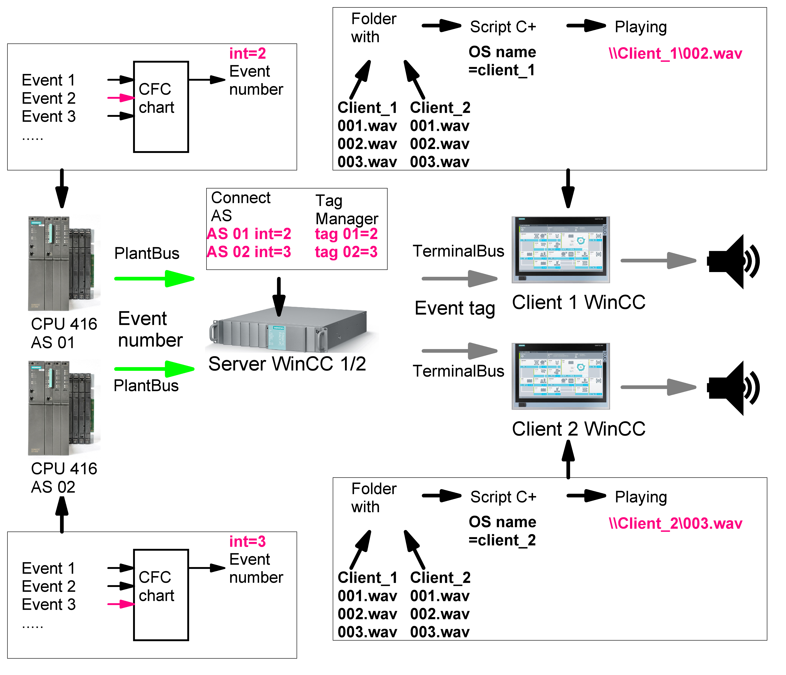

Event Audio Notification System Architecture

B. Hardware
The monitors used by the two operators in the control room have built-in speakers, which can be used for audio output via DisplayPort.
The HMI panels do not have speakers. This was addressed by purchasing USB PC speakers, which receive both power and audio through a single USB connection. The speakers are detected as an audio device in Device Manager; no separate driver was required, and they worked immediately.
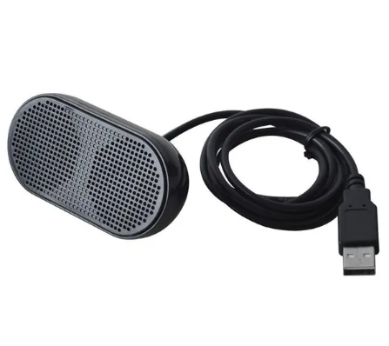

USB speaker

C. Division of Functions Between the PLC and WinCC
The PLC receives BOOL signals, processes them, places events in a queue, and sends a number to WinCC indicating which sound file should be played.
WinCC receives the number, maps it to the OS client name, checks whether the corresponding listening group is enabled, and plays the sound.

D. Ring Architecture
Because a function block has a fixed number of inputs and the required number of sound events is not known in advance, I adopted a ring architecture using two types of PLC function blocks:
1. Head FB – sends the event number.
2. Extension FB – connects to the Head FB and receives BOOL event signals.
The blocks are connected in a ring. The Head FB polls the blocks sequentially, while the extension blocks pass the states of their inputs around the ring. As the system grows, additional Extension FBs can simply be added to the ring. Each Extension FB must have its own sequential ID.
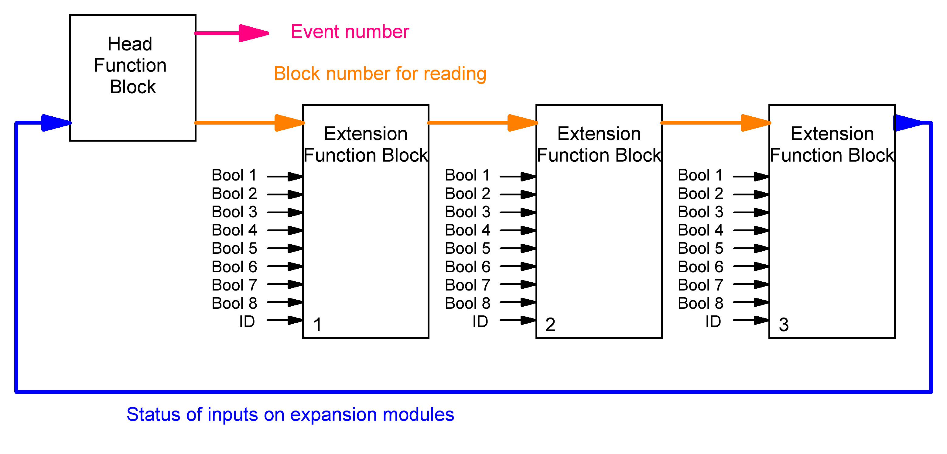

Ring Structure

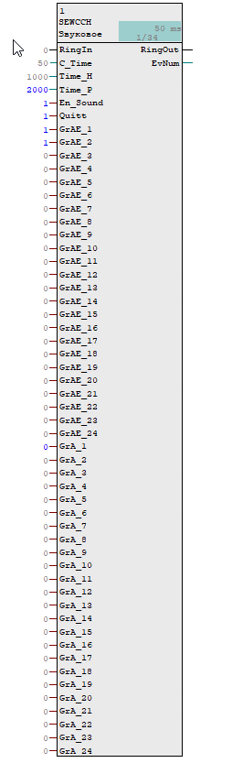
IV. PLC Implementation

A. Head Block (Head FB)

1. Purpose
One Head FB is assigned to each operator OS. It polls the extension blocks, manages the playback queue, and enables or disables listening groups.
Some variables have been assigned the 'S7_m_c=TRUE' attribute so that their values can be displayed on the faceplate. These include listening-group activation and the overall sound-system enable state.

2. Inputs
RingIn: Input of the ring structure, connected to the last Extension FB.
C_Time: Execution time of the OB cycle containing this FB. The diagram shows 50 ms.
Time_H: Time for which the event number is held so that WinCC has time to read the tag.
Time_P: Pause between events to prevent sounds from overlapping.
En_Sound: Master sound-notification enable switch, controlled from the OS.
Quitt: Acknowledgement signal used for notifications that require acknowledgement.
C_Time: OB cycle time in which the block runs, used for accurate time calculation.
GrAE_1…24: External pulse inputs for enabling/disabling listening groups.
GrA_1…24: Listening-group activation statuses, controlled from the OS.

3. Outputs
RingOut: Output of the ring structure, connected to the first Extension FB.
EvNum: Event number.

B. Extension Block (Extension FB)
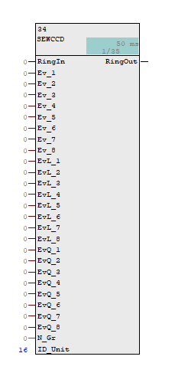
1. Purpose
The block receives BOOL signals and passes them to the Head FB through the ring structure. Multiple Extension FBs can be used.

2. Inputs
RingIn: Input of the ring structure.
Ev_1…8: BOOL event signals.
EvL_1…8: Signal parameter – repeat mode. If TRUE (1), the sound repeats while the corresponding input signal remains active. If FALSE (0), it plays once.
Ev_Q_1…8: Signal parameter – acknowledgement mode. If TRUE (1), the sound repeats until acknowledged. If FALSE (0), it plays once.
The two parameters must not be enabled simultaneously; for example, EvL_1=TRUE and EvQ_1=TRUE must not be used together.
N_Gr: Number of the listening group to which events received by this block belong.
ID_Unit: Sequential ID of the block in the ring. It is assigned automatically and must be unique within the ring. It is used to generate the final event number.

3. Outputs
RingOut: Output of the ring structure.

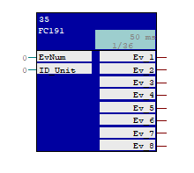
C. Decoder FC
1. Purpose
This block became necessary when I discovered that not all signals from other controllers are available in the controller hosting the system. It addresses this by receiving an event number from a Head FB in another controller via the plantbus SEND/RECEIVE interface and decoding it into one of eight BOOL signals, which can then be connected to an Extension FB. An example is provided in Section VI, “Implementation in PCS 7 / WinCC.”
2. Inputs:
EvNum: Event number from the Head FB.
ID_Unit: ID of the Extension FB whose eight BOOL signals are required.
3. Outputs:
Ev_1…8: Event signals sent to the Extension FB.

D. PLC Logic Operation
1. Automatic ID Assignment
On the first startup, the Head FB sends the value 0 in the ID_BlockSerial variable around the ring. The first Extension FB increments this value by 1, assigns it to its ID_Unit, and passes it to the next block. Each subsequent block does the same. This automatically assigns an ID to every Extension FB. The Head FB then polls each Extension FB in sequence until it receives an event.

2. Determining the Number of Blocks
The last Extension FB sends its ID to the Head FB, allowing the Head FB to determine the total number of Extension FBs in the ring.

3. Sequential Polling
The blocks are polled sequentially, starting with ID 1 and continuing to the last block, after which the cycle repeats.

4. Listening Groups
This feature allows the operator to choose which equipment units to monitor by sound.
The groups are selected using checkboxes on the faceplate.

5. Event Detection
When a BOOL signal becomes active at an Extension FB and its listening group is enabled, the block sends the event status to the Head FB through the ring.

6. Generating the Event Number
For example, suppose a signal arrives at Ev_5 on the Extension FB with ID 8. The event number is calculated as (8 × 10) + 5 = 85. If the listening group for this Extension FB is enabled in the Head FB, the event is sent to the EvNum output.

7. Controlling Playback Timing
The value at the EvNum output remains active for Time_H (1000 ms by default). This allows WinCC sufficient time to read the tag. After Time_H expires, EvNum is set to 0, followed by a pause lasting Time_P.

8. Pause Between Events
The pause prevents sounds from overlapping. Time_P is calculated as the sound duration minus Time_H. The longest sound in my system is 5 seconds, so Time_P is set to 4000 ms. Once the Head FB has polled all Extension FBs, it starts again from the beginning.

9. Handling Multiple Events
If several events occur simultaneously, the Head FB polls each Extension FB in sequence and outputs the corresponding sound number.

10. Acknowledgement and Repeat Modes
Acknowledgement mode: If Ev_Q_1…8 is TRUE for the corresponding input on an Extension FB, playback repeats until the operator acknowledges the event. If FALSE, the sound plays once.
Repeat mode: If EvL_1…8 is TRUE for the corresponding input on an Extension FB, playback repeats while the corresponding input signal remains active. If FALSE, the sound plays once.

V. WinCC Implementation
A. Playback Script on the Client Computer
1. Identifying the Current Client
The script identifies the OS client by its computer name, selects the corresponding sound folder and tag from which to read the playback value, then selects and plays the sound file matching that tag value.
// ---------------------------------------------------------------------
// 1. Get the computer name
// ---------------------------------------------------------------------
strcpy(machine, GetTagChar("@local::@LocalMachineName"));

// ---------------------------------------------------------------------
// 2. IDENTIFY THE COMPUTER
// ---------------------------------------------------------------------

// ---- Operators ----
if (strcmp(machine, "WCCCL1") == 0)
{
strcpy(folder, "D:\\Project\\CL\\SoundEvents\\Op1"); // Folder for client 1
strcpy(tagToRead, "AS_01/1/1.EvNum"); // Tag for client 1
}
else if (strcmp(machine, "WCCCL2") == 0)
{
strcpy(folder, "D:\\Project\\_CL\\SoundEvents\\Op2"); // Folder for client 2
strcpy(tagToRead, "AS_02/2/2.EvNum"); // Tag for client 2
}
else
{
return 0; // Unknown computer
}

// ---------------------------------------------------------------------
// 3. READ THE TAG
// ---------------------------------------------------------------------
curVal = GetTagDWord(tagToRead);

2. Sound Folders
To my surprise, placing the sound folder in the root directory of the client project also caused it to be downloaded to client computers together with the project from the SIMATIC environment. This is very convenient and keeps the project consistent across all machines.
I found a website that converts text to speech for free, then edited the audio in an audio editor. In total, approximately 150 messages were created.

3. Receiving the Event Number
The WinCC client receives EvNum from the controller. The script handles the rest.

4. Selecting the WAV File
The file name uses the format xxx.wav. For EvNum=5, the selected file is 005.wav; for EvNum=48, it is 048.wav. This allows up to 99 Extension FBs, each with 8 event inputs: 99 × 8 = 792 messages per OS. If necessary, the script can be modified to accept filenames in the xxxx.wav format, increasing the number of messages by approximately a factor of ten.

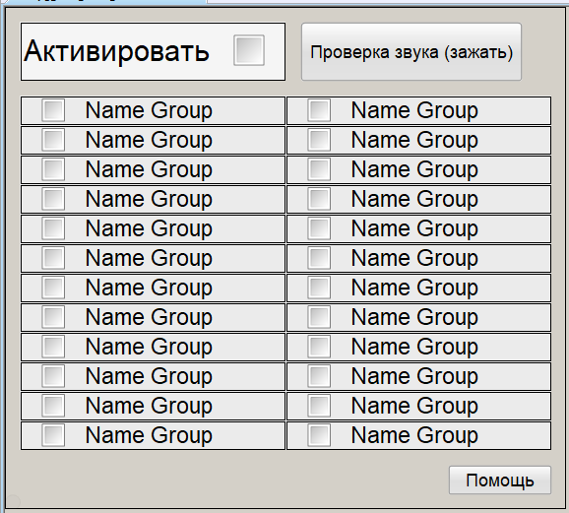
B. Head Block Faceplate
1. Listening Groups
By selecting checkboxes, the operator chooses which listening groups to hear.
2. “Enable”
Checkbox for enabling or disabling the sound notification system as a whole.
3. Sound Test
A button is provided to test audio playback.

C. Control Button
A picture window was placed over the Horn button. It contains buttons for all Head FBs, but each button is displayed only on its designated computer.
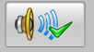
1. Acknowledgement
Left-clicking the button sends an acknowledgement signal. This applies only to signals configured in the Extension FB using the Ev_Q_1…8 parameter.

2. Opening the Faceplate
Right-clicking opens the faceplate.

VI. Implementation in PCS 7 / WinCC
- Integrated View in the System CFC Chart
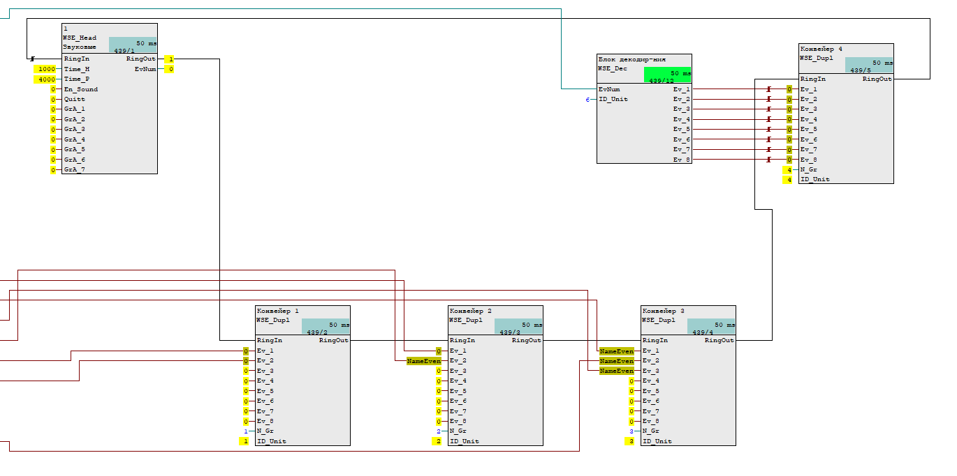
The diagram shows one Head FB and four Extension FBs connected in a ring. It also includes a Decoder FC, which decodes an event number from a Head FB in another controller into a BOOL signal for transfer to Extension FB 4. Note that the IDs of the Extension FBs were assigned automatically.

VII. Example of System Operation
A. Event Occurrence
A BOOL TRUE signal arrives at input Ev_5 of Extension FB ID 14.
B. Head FB Operation
The Head FB receives the event and outputs the number 145 via EvNum.
C. WinCC Client Operation
The WinCC client script detects a change in the relevant tag value, selects the sound from the folder assigned to that client, and plays 145.wav. The message is “Conveyor 5, belt mistracking.”

VIII. Adding New Events
A. PLC
Simply add a new Extension FB at the end of the ring, connect the BOOL event signals to it, and download the changes to the controller in change mode.
B. Adding New Sound Files
Add the new sound files using numeric names based on the new Extension FB ID. For example, if the new Extension FB is assigned ID 16, the files must be numbered 161 through 168.

IX. Conclusion

The development of the audio notification system began with a simple goal: to add an audio channel to the existing WinCC visualization so that operators could respond more quickly to important events.
Instead of a separate sound playback script, a complete event-processing system called SEWCCH was developed, comprising PLC and WinCC components. The PLC detects, processes, and outputs events sequentially, while WinCC plays the corresponding sounds on the appropriate client.
The system’s scalability is based on a ring architecture consisting of a Head FB and Extension FBs. Automatic ID assignment means that adding new blocks does not require changes to the existing Head FB logic. To add new events, the required signals simply need to be connected to another Extension FB and the corresponding sound files added.
The system also supports distributing audio events among different OS clients, managing listening groups, selecting playback modes, and processing multiple events sequentially. New blocks can be added and logic changes implemented without restarting the controller.
It is worth noting that the original task proved more complex than simply playing WAV files. Development also required solving automatic block addressing, data exchange between blocks, generation of a unified event number, playback queue management, and communication between the PLC and WinCC.
The resulting solution is not tied to a single signal or process unit. Its architecture allows it to be used as an additional audio notification mechanism in Siemens PCS 7 projects with varying numbers of process units and client stations.

